“No one has died from the coronavirus” Important revelations shared by Dr Stoian Alexov, President of the Bulgarian Pathology Association

Rosemary Frei and Patrick Corbett
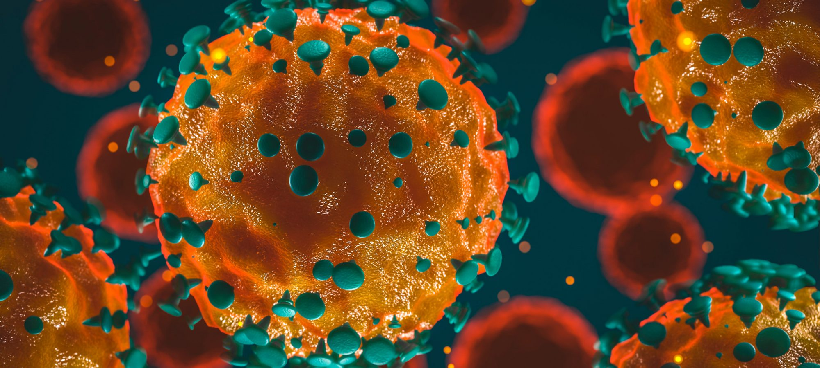

A high-profile European pathologist is reporting that he and his colleagues across Europe have not found any evidence of any deaths from the novel coronavirus on that continent.
Dr. Stoian Alexov called the World Health Organization (WHO) a “criminal medical organization” for creating worldwide fear and chaos without providing objectively verifiable proof of a pandemic.
Another stunning revelation from Bulgarian Pathology Association (BPA) president Dr. Alexov is that he believes it’s currently “impossible” to create a vaccine against the virus.
He also revealed that European pathologists haven’t identified any antibodies that are specific for SARS-CoV-2.
These stunning statements raise major questions, including about officials’ and scientists’ claims regarding the many vaccines they’re rushing into clinical trials around the world.
They also raise doubt about the veracity of claims of discovery of anti-novel-coronavirus antibodies (which are beginning to be used to treat patients).
Novel-coronavirus-specific antibodies are supposedly the basis for the expensive serology test kits being used in many countries (some of which have been found to be unacceptably inaccurate).
And they’re purportedly key to the immunity certificates coveted by Bill Gates that are about to go into widespread use — in the form of the COVI-PASS — in 15 countries including the UK, US, and Canada.
Dr. Alexov made his jaw-dropping observations in a video interview summarizing the consensus of participants in a May 8, 2020, European Society of Pathology (ESP) webinar on COVID-19.
The May 13 video interview of Dr. Alexov was conducted by Dr. Stoycho Katsarov, chair of the Center for Protection of Citizens’ Rights in Sofia and a former Bulgarian deputy minister of health. The video is on the BPA’s website, which also highlights some of Dr. Alexov’s main points.
We asked a native Bulgarian speaker with a science background to orally translate the video interview into English. We then transcribed her translation. The video is here and our English transcript is here.
Among the major bombshells Dr. Alexov dropped is that the leaders of the May 8 ESP webinar said no novel-coronavirus-specific antibodies have been found.
The body forms antibodies specific to pathogens it encounters. These specific antibodies are known as monoclonal antibodies and are a key tool in pathology. This is done via immunohistochemistry, which involves tagging antibodies with colours and then coating the biopsy- or autopsy-tissue slides with them. After giving the antibodies time to bind to the pathogens they’re specific for, the pathologists can look at the slides under a microscope and see the specific places where the coloured antibodies — and therefore the pathogens they’re bound to – are located.
Therefore, in the absence of monoclonal antibodies to the novel coronavirus, pathologists cannot verify whether SARS-CoV-2 is present in the body, or whether the diseases and deaths attributed to it indeed were caused by the virus rather than by something else.
It would be easy to dismiss Dr. Alexov as just another crank ‘conspiracy theorist.’ After all many people believe they’re everywhere these days, spreading dangerous misinformation about COVID-19 and other issues.
In addition, little of what Dr. Alexov alleges was the consensus from the May 8 webinar is in the publicly viewable parts of the proceedings.
But keep in mind that whistleblowers often stand alone because the vast majority of people are afraid to speak out publicly.
Also, Dr. Alexov has an unimpugnable record and reputation. He’s been a physician for 30 years. He’s president of the BPA, a member of the ESP’s Advisory Board and head of the histopathology department at the Oncology Hospital in the Bulgarian capital of Sofia.
On top of that, there’s other support for what Dr. Alexov is saying.
For example, the director of the Institute of Forensic Medicine at the University Medical Center Hamburg-Eppendorf in Germany said in media interviews that there’s a striking dearth of solid evidence for COVID-19’s lethality.
“COVID-19 is a fatal disease only in exceptional cases, but in most cases it is a predominantly harmless viral infection,” Dr. Klaus Püschel told a German paper in April. Adding in another interview:
In quite a few cases, we have also found that the current corona infection has nothing whatsoever to do with the fatal outcome because other causes of death are present, for example, a brain hemorrhage or a heart attack […] [COVID-19 is] not particularly dangerous viral disease […] All speculation about individual deaths that have not been expertly examined only fuel anxiety.”
Also, one of us (Rosemary) and another journalist, Amory Devereux, documented in a June 9 Off-Guardian article that the novel coronavirus has not fulfilled Koch’s postulates.
These postulates are scientific steps used to prove whether a virus exists and has a one-to-one relationship with a specific disease. We showed that to date no one has proven SARS-CoV-2 causes a discrete illness matching the characteristics of all the people who ostensibly died from COVID-19. Nor has the virus has been isolated, reproduced and then shown to cause this discrete illness.
In addition, in a June 27 Off-Guardian article two more journalists, Torsten Engelbrecht and Konstantin Demeter, added to the evidence that “the existence of SARS-CoV-2 RNA is based on faith, not fact.”
The pair also confirmed “there is no scientific proof that those RNA sequences [deemed to match that of the novel coronavirus] are the causative agent of what is called COVID-19.”
Dr. Alexov stated in the May 13 interview that:
the main conclusion [of those of us who participated in the May 8 webinar] was that the autopsies that were conducted in Germany, Italy, Spain, France and Sweden do not show that the virus is deadly.”
He added that:
What all of the pathologists said is that there’s no one who has died from the coronavirus. I will repeat that: no one has died from the coronavirus.”
Dr. Alexov also observed there is no proof from autopsies that anyone deemed to have been infected with the novel coronavirus died only from an inflammatory reaction sparked by the virus (presenting as interstitial pneumonia) rather than from other potentially fatal diseases.
Another revelation of his is that:
“We need to see exactly how the law will deal with immunization and that vaccine that we’re all talking about, because I’m certain it’s [currently] not possible to create a vaccine against COVID. I’m not sure what exactly Bill Gates is doing with his laboratories – is it really a vaccine he’s producing, or something else?”
As pointed to above, the inability to identify monoclonal antibodies for the virus suggests there is no basis for the vaccines, serological testing and immunity certificates being rolled out around the globe at unprecedented speed and cost. In fact, there is no solid evidence the virus exists.
Dr. Alexov made still more important points. For example, he noted that, in contrast to the seasonal influenza, SARS-CoV-2 hasn’t been proven to kill youth:
[With the flu] we can find one virus which can cause a young person to die with no other illness present […] In other words, the coronavirus infection is an infection that does not lead to death. And the flu can lead to death.”
(There have been reports of severe maladies such as Kawasaki-like disease and stroke in young people who were deemed to have a novel-coronavirus infection. However, the majority of published papers on these cases are very short and include only one or only a small handful of patients. Moreover, commenters on the papers note it’s impossible to determine the role of the virus because the papers’ authors did not control sufficiently, if at all, for confounding factors. It’s most likely that children’s deaths attributed to COVID-19 in fact are from multiple organ failure resulting from the combination of the drug cocktail and ventilation that these children are subjected to.)
Dr. Alexov therefore asserted that:
the WHO is creating worldwide chaos, with no real facts behind what they’re saying.”
Among the myriad ways the WHO is creating that chaos is by prohibiting almost all autopsies of people deemed to have died from COVID-19. As a result, reported Dr. Alexov, by May 13 only three such autopsies had been conducted in Bulgaria.
Also, the WHO is dictating that everyone said to be infected with the novel coronavirus who subsequently dies must have their deaths attributed to COVID-19.
“That’s quite stressful for us, and for me in particular, because we have protocols and procedures which we need to use,” he told Dr. Katsarov. “…And another pathologist 100 years from now is going to say, ‘Hey, those pathologists didn’t know what they were doing [when they said the cause of death was COVID-19]!’ So we need to be really strict with our diagnoses, because they could be proven [or disproven], and they could be checked again later.”
He disclosed that pathologists in several countries in Europe, as well as in China, Australia and Canada are strongly resisting the pressure on them to attribute deaths to COVID-19 alone:
I’m really sad that we need to follow the [WHO’s] instructions without even thinking about them. But in Germany, France, Italy and England they’re starting to think that we shouldn’t follow the WHO so strictly, and [instead] when we’re writing the cause of death we should have some pathology [results to back that up] and we should follow the protocol. [That’s because] when we say something we need to be able to prove it.”
(He added that autopsies could have helped confirm or disprove the theory that many of the people deemed to have died of COVID-19 in Italy had previously received the H1N1 flu vaccine. Because, as he noted, the vaccine suppresses adults’ immune systems and therefore may have been a significant contributor to their deaths by making them much more susceptible to infection.)
Drs. Alexov and Katsarov agreed that yet another aspect of the WHO-caused chaos and its fatal consequences is many people are likely to die soon from diseases such as cancer because the lockdowns, combined with the emptying of hospitals (ostensibly to make room for COVID-19 patients), halted all but the most pressing procedures and treatments.
They also observed these diseases are being exacerbated by the fear and chaos surrounding COVID-19.
We know that stress significantly suppresses the immune system, so I can really claim 200% that all the chronic diseases will be more severe and more acute per se. Specifically in situ carcinoma – over 50% of these are going to become more invasive […] So I will say that this epidemic isn’t so much an epidemic of the virus, it’s an epidemic of giving people a lot of fear and stress.”
In addition, posited Dr. Alexov, as another direct and dire result of the pandemic panic many people are losing faith in physicians.
Because in my opinion the coronavirus isn’t that dangerous, and how are people going to have trust in me doing cancer pathology, much of which is related to viruses as well? But nobody is talking about that.”
We emailed Dr. Alexov several questions, including asking why he believes it’s impossible to create a vaccine against COVID-19.
He didn’t answer the questions directly. Dr. Alexov instead responded:
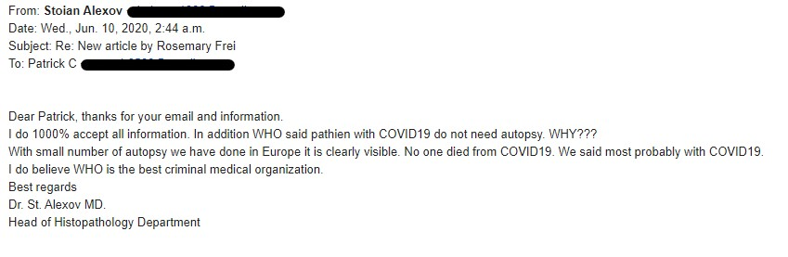
We also emailed five of Dr. Alexov’s colleagues in the ESP asking them to confirm Dr. Alexov’s revelations. We followed up by telephone with two of them. None responded.
Why didn’t Dr. Alexov or his five colleagues answer our questions?
We doubt it’s due to lack of English proficiency.
It’s more likely because of the pressure on pathologists to follow the WHO’s directives and not speak out publicly. (And, on top of that, pathology departments depend on governments for their funding.)
Nonetheless, pathologists like Drs. Alexov and Püschel appear to be willing to step out and say that no one has died from a novel-coronavirus infection.
Perhaps that’s because pathologists’ records and reputations are based on hard physical evidence rather than on subjective interpretation of tests, signs and symptoms. And there is no hard physical evidence that COVID-19 is deadly.

